

**MACAU UNIVERSITY OF SCIENCE AND TECHNOLOGY**

**School of Computer Science and Engineering**

**Faculty of Innovation Engineering**

**<<Software Project for Course Software Engineering>>**

Homework ID : Task1-Project Proposal

Report Title : Tarturus, a game based on "Vampire Survivors"

Student Name : Yu Siyuan, Liu Benhuang

Student No. : 1220004131, 1220004875

Date : 23/9/2024

# Abstract

This proposal outlines the development of a game based on the mechanics of "Vampire Survivors" with enhancements in graphics and interactivity. Our project aims to enhance user engagement through improved game dynamics and storytelling.

# Table of Contents

Abstract II

Table of Contents III

List of Figures IV

Chapter 1 Introduction 5

Chapter 2 Problem Diagnosis 7

Chapter 3 Proposed Treatment 8

3.1 Narrative Integration 8

3.2 Visual and Audio Enhancements 8

Chapter 4 Plan of Work 9

4.1 Research Phase: Gathering Feedback from Existing Games and Literature(1 week) 9

4.2 Design Phase(2-3 week) 9

4.3 Development Phase(4-6 week) 9

4.4 Test Phase(7-8 week) 10

References 11

# List of Figures

Figure 1-1 The image of Vampire Survivors 5

Figure 1‑2 Battle screen 5

Figure 1-3 The image of Protagonists 6

Figure 3-1 Use Cubase to make the game music 8

# Introduction

The project URL has been uploaded to github: <https://github.com/steinsgo/Tarturus>

Our project proposes the development of a game that draws inspiration from the immensely popular genre exemplified by "Vampire Survivors." This new title will be engineered to offer a gameplay experience that is both challenging and deeply rewarding, appealing to fans of both survival and role-playing game (RPG) genres.

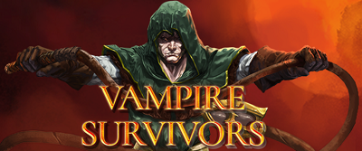

Fig.1-1 The image of Vampire Survivors

The core of our game's design revolves around a robust survival mechanic that requires players to manage resources, fend off increasingly difficult waves of enemies, and strategically navigate hostile environments. This survival aspect will be seamlessly integrated with rich RPG elements such as character leveling, skill upgrades, and a branching character build that responds to player choices, ensuring a dynamic gaming experience.

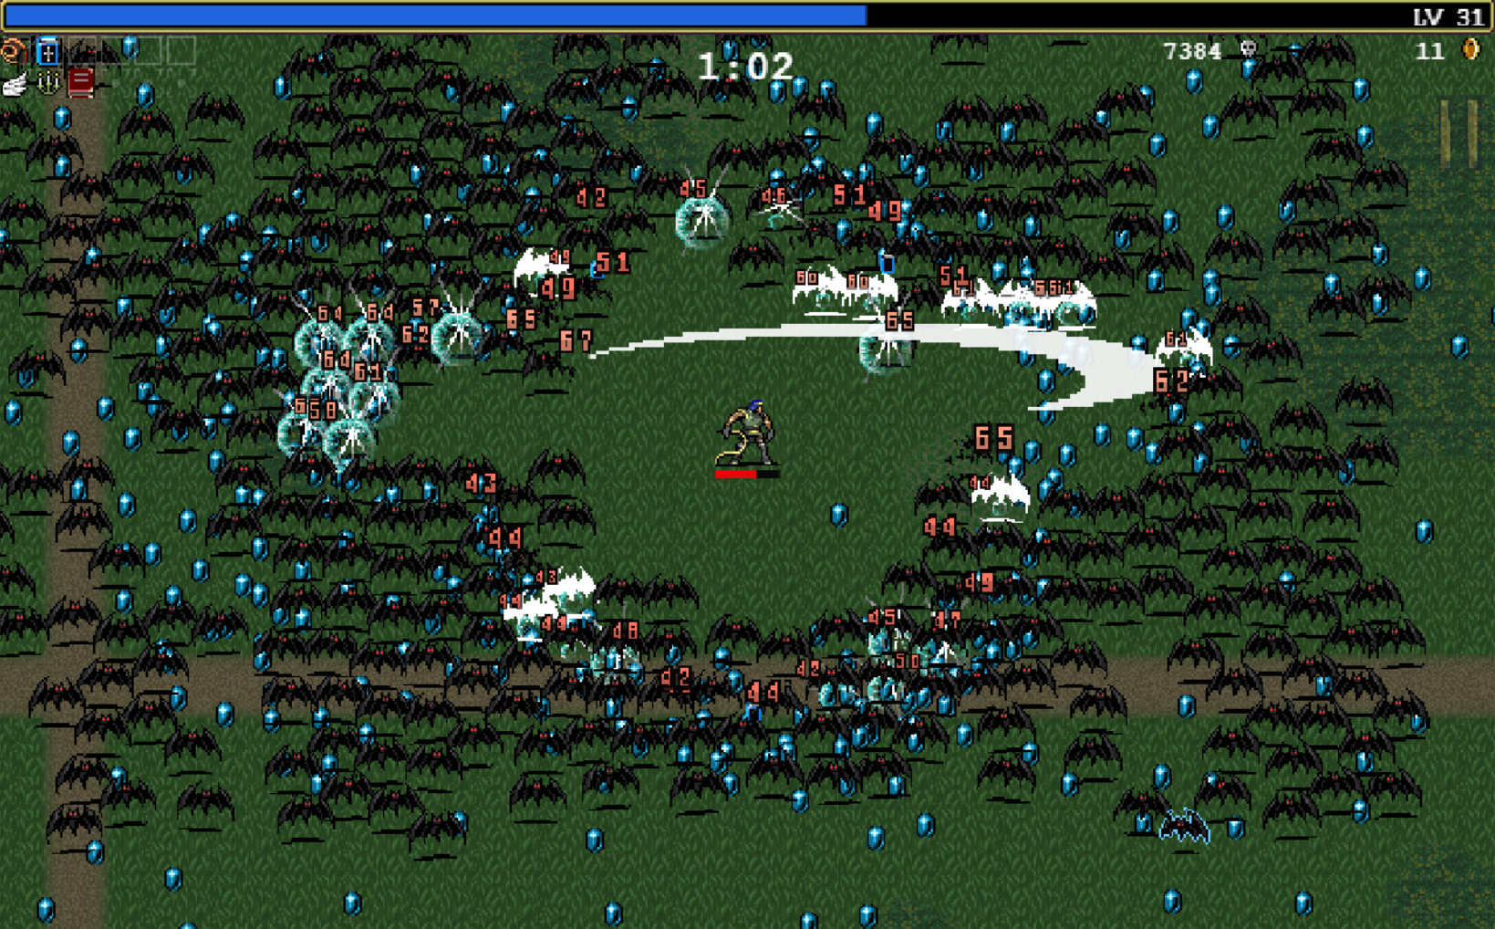

Fig.1-2 Battle screen

Players will embark on a journey through a meticulously crafted world that offers a blend of predefined story arcs and procedurally generated environments. This combination ensures that each playthrough remains unique, while still driving forward a coherent and engaging narrative.

Additionally, the game will feature a reward system that recognizes player achievement and skill progression. This system is designed to offer tangible benefits for gameplay, such as unlocking special abilities or character enhancements, which provide players with a sense of achievement and encourage continued engagement with the game.

Through this innovative blend of survival mechanics and RPG elements, our project aims to captivate a diverse audience, providing an immersive and varied gaming experience that pushes the boundaries of what games in this genre can offer.

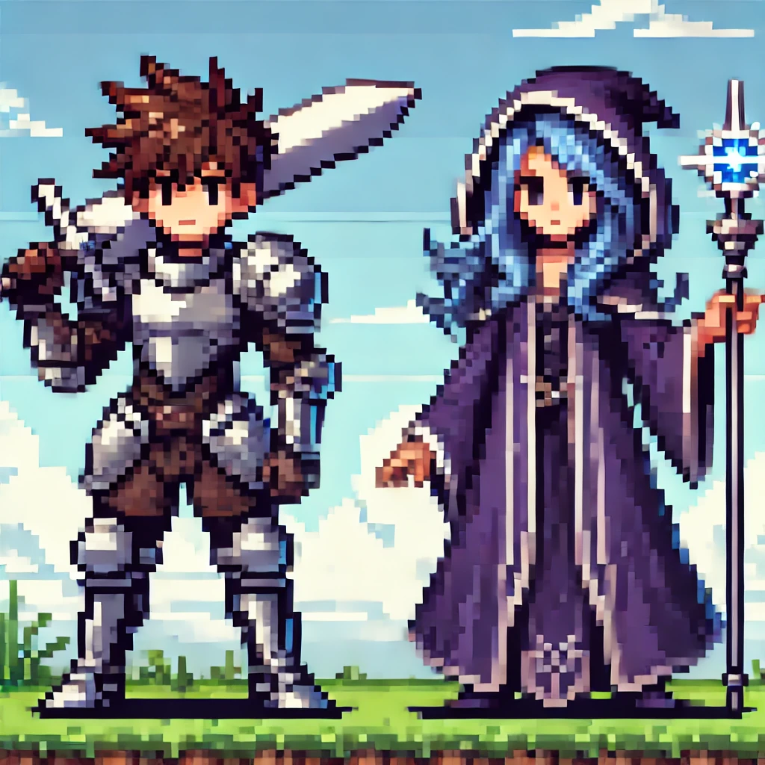

Fig.1-3 The image of Protagonists

**Game Functionality:**

* Vampire Survivors is a casual game in which players make choices to make their characters stronger and stronger, and have no fear of being surrounded by monsters

# 

# Problem Diagnosis

Current games in the survivor genre frequently exhibit a lack of depth in narrative and character development, often focusing primarily on gameplay mechanics and survival challenges. Our thorough analysis, supported by observations and extensive feedback gathered from various game forums and community discussions, reveals a significant player demand for more enriched and engaging storylines. Players express a desire for games that not only test their survival skills but also engage them emotionally and intellectually through complex narratives and well-developed characters. Many existing titles in this genre provide minimal backstory or character motivation, which can result in a less immersive experience.

Enhancing these aspects could significantly increase player retention and satisfaction. By introducing intricate plots that unfold through player actions and decisions, coupled with detailed character growth that reflects the challenges faced and overcome, our game aims to set a new standard for narrative depth in survival games. Players would encounter moral dilemmas, make strategic decisions that influence the game’s outcome, and see their characters grow not only in power but also in personality and complexity.

This approach not only satisfies existing fans of the genre but also attracts new players who seek a more story-driven gaming experience. Our project will prioritize these elements to capture and maintain player interest, making our game a standout addition to the survivor genre.

# Proposed Treatment

## 3.1 Narrative Integration

Our game aims to transcend traditional survival mechanics by embedding a deeply engaging and evolving narrative that progresses dynamically with the player's actions. This narrative integration is designed not only to enhance the immersive quality of the game but also to provide a richer, more personal gaming experience that resonates with players on an emotional level.

**Story Development:** The storyline of our game will be structured around key plot points that advance as players achieve specific milestones or make significant decisions. This approach allows the narrative to unfold in a non-linear fashion, giving players the freedom to explore different story arcs based on their choices. Whether it’s forming alliances, making moral decisions that affect the game world, or uncovering hidden secrets, each player’s journey will be unique, contributing to high replay value.

## 3.2 Visual and Audio Enhancements

To create an immersive and captivating environment that enhances the overall gameplay, our project places significant emphasis on advanced visual and audio enhancements. These elements are critical in bringing the game’s world to life, making each player’s experience unique and engaging.

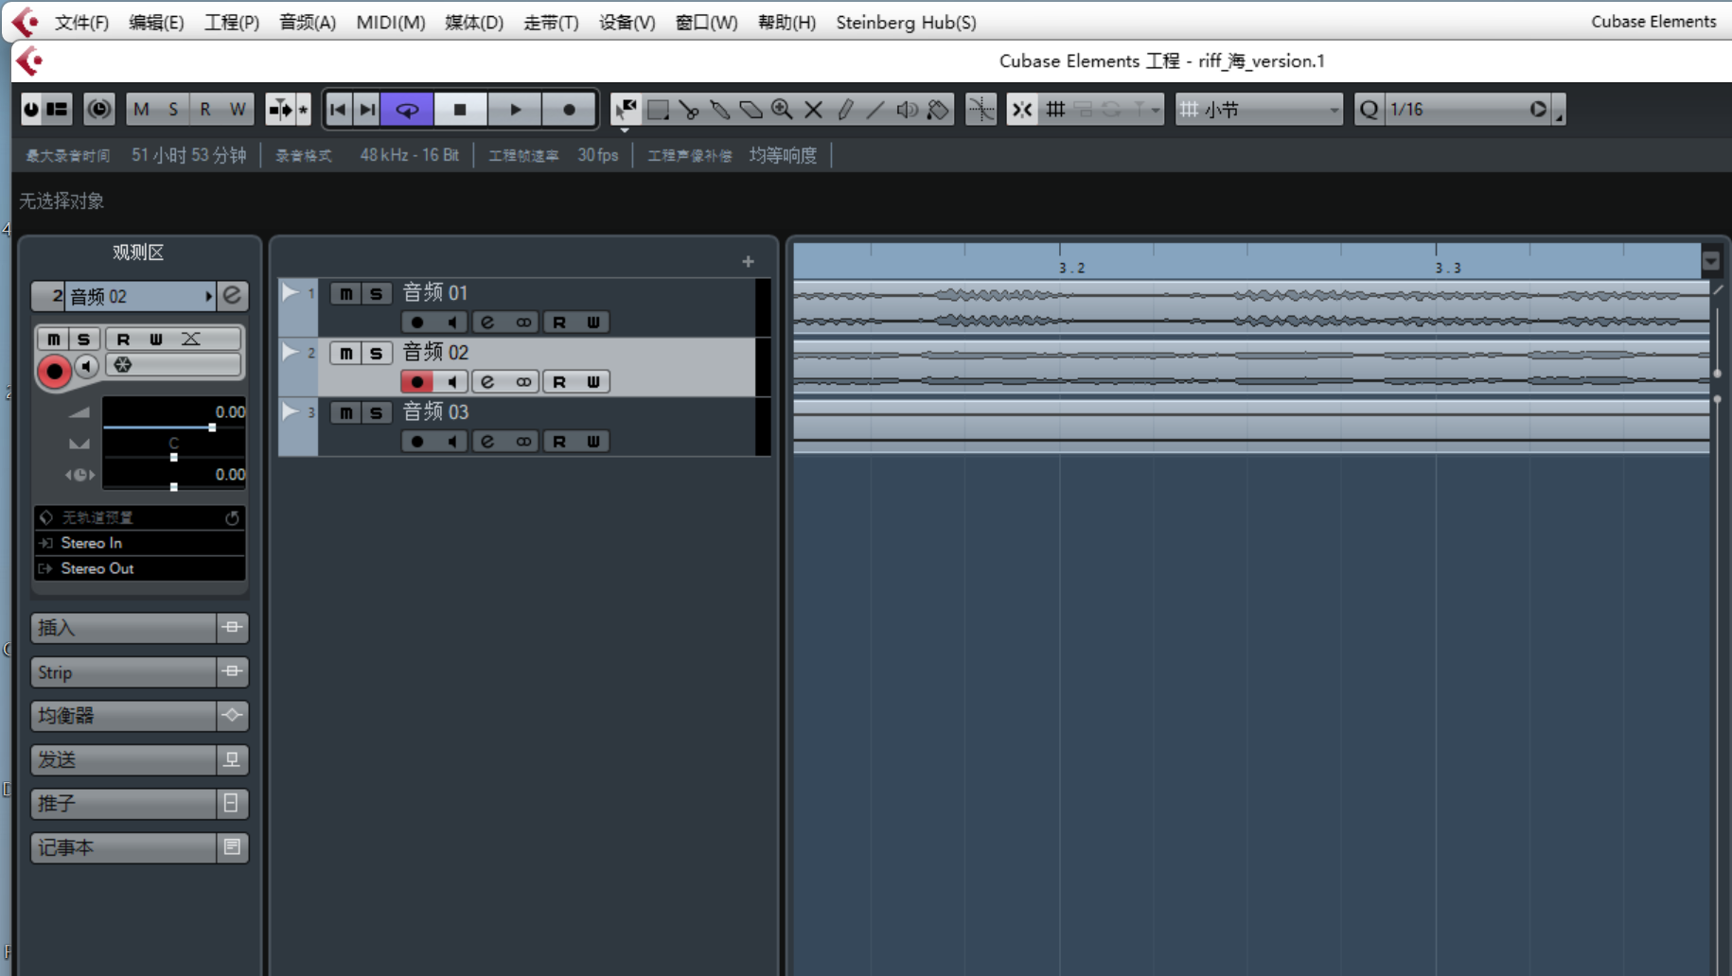

3-1 Use Cubase to make the game music

# Plan of Work

**Team member:**

Liu Benhuang(Designer): Responsible for creating functional game feature designs.

Yu Siyuan(Programmer): Responsible for optimizing game logic and feature implementation.

## 4.1 Research Phase: Gathering Feedback from Existing Games and Literature(1 week)

To directly capture player expectations and preferences, we will design and distribute surveys to potential players. Additionally, structured interviews with avid gamers and industry experts will be conducted to gather in-depth insights.

## 4.2 Design Phase(2-3 week)

**Game Design Document (GDD):** A detailed GDD will be created, outlining the game’s concept, gameplay mechanics, storyline, character bios, art and sound specifications, and technical requirements. This document will serve as the blueprint for all subsequent development efforts.

**Prototyping:** Early prototypes of the game will be developed to test and refine core gameplay mechanics and user interfaces. These prototypes will be crucial for validating the game concept and for early user testing.

## 4.3 Development Phase(4-6 week)

**1.Setup Development Environment:** Configure all necessary development tools and platforms.

**2.Implement Core Game Mechanics:** Begin coding the main gameplay mechanics based on the prototypes approved in the design phase. This includes player movement, game rules, interaction models, and core loops that define the gameplay experience.

**3.Develop Levels and Environments:** Construct the game’s environments and levels using the art assets created during the design phase. This step involves detailed level design, environmental effects, and ensuring that each area supports the gameplay mechanics effectively.

**4.Integrate Story Elements:** Code the narrative elements into the game, ensuring that story sequences, dialogues, and character development events are triggered at appropriate times and enhance the overall game experience.

**5.Artificial Intelligence Integration:** Implement AI behaviors for non-player characters and enemies. This includes pathfinding, decision-making, and tactical reactions to player actions, adding depth and challenge to the game.

**6.Sound Integration:** Collaborate with sound designers to integrate audio elements, including background music, sound effects, and voice overs, ensuring they trigger correctly based on game events and player actions.

**7.Optimization and Performance Tuning:** Continuously test the game on various hardware setups to identify performance bottlenecks. Optimize code, graphics, and assets to ensure smooth performance and good frame rates across all supported platforms.

**8.Bug Fixing and Quality Assurance:** Conduct thorough testing phases to identify and fix bugs. This includes unit testing, integration testing, and full playthroughs to ensure that all elements of the game function correctly and are free from glitches.

## 4.4 Test Phase(7-8 week)

Before published, testing phases will involve community testers to provide real-world feedback on gameplay, usability, and engagement. These sessions are essential to refine game mechanics and narrative delivery before final release.

# References

1. *Fandom. (n.d.). Vampire Survivors Wiki. Retrieved September 22, 2024, from* [*https://vampire-survivors.fandom.com/wiki/Vampire_Survivors_Wiki*](https://vampire-survivors.fandom.com/wiki/Vampire_Survivors_Wiki)
2. Aylett, R. (1999). ‘Narrative in Virtual Environments -Towards Emergent Narrative’. AAAI Technical Report FS-99-01. pp. 83-86.
3. Björk, S. Lundgren, S. & Holopainen, J. (2003). ‘Game Design Patterns.’ In: Digital Games Research Conference 2003. The Netherlands: University of Utrecht
4. Chauvin, S. Levieux, G. Donnart, J. Natkin, S. ‘Making sense of emergent narratives: An architecture supporting player-triggered narrative processes’. IEEE Conference on Computational Intelligence and Games (CIG), Aug 2015, Tainan, France. pp.91-98.